**PROJECT REPORT**

**ANALYZING THE PERFORMANCE & EFFICIENCY OF THE RADISSON HOTELS USING DATA VISUALIZATION TECHNIQUES**

1. **INTRODUCTION**
   1. **Overview**

The hotel industry is a broad category of businesses that provide lodging services for travelers tourists. This can include a wide range of establishments, from luxury resorts to budget-friendly motels, as well as extended stay hotels, boutique hotels and more. Hotels can be found in nearly every corner of the world, and are often a major component of the tourism and travel industry in a given area.

Radisson owns multiple five star hotels across India. They have been in hospitality industry for the past 100 years. Due to strategic moves from other competitors and ineffective decision making in management, Radisson is losing its market share and revenue in the luxury/business hotels category. As a strategic move, the managing director of Radisson wanted to incorporate Business and Data Intelligence in order to regain their market share and revenue.

* 1. **Purpose**

In this analysis we know that the hotels prons and cons in their capacity, revenue, bookings, customers demand, etc. It helps the hotels to increase their performance as well as the efficiency. Our task is to create an analytics dashboard & story to provide them insights to make better business decisions.

1. **PROBLEM DEFINING AND DESIGN THINKING**

**2.1. Empathy Map**

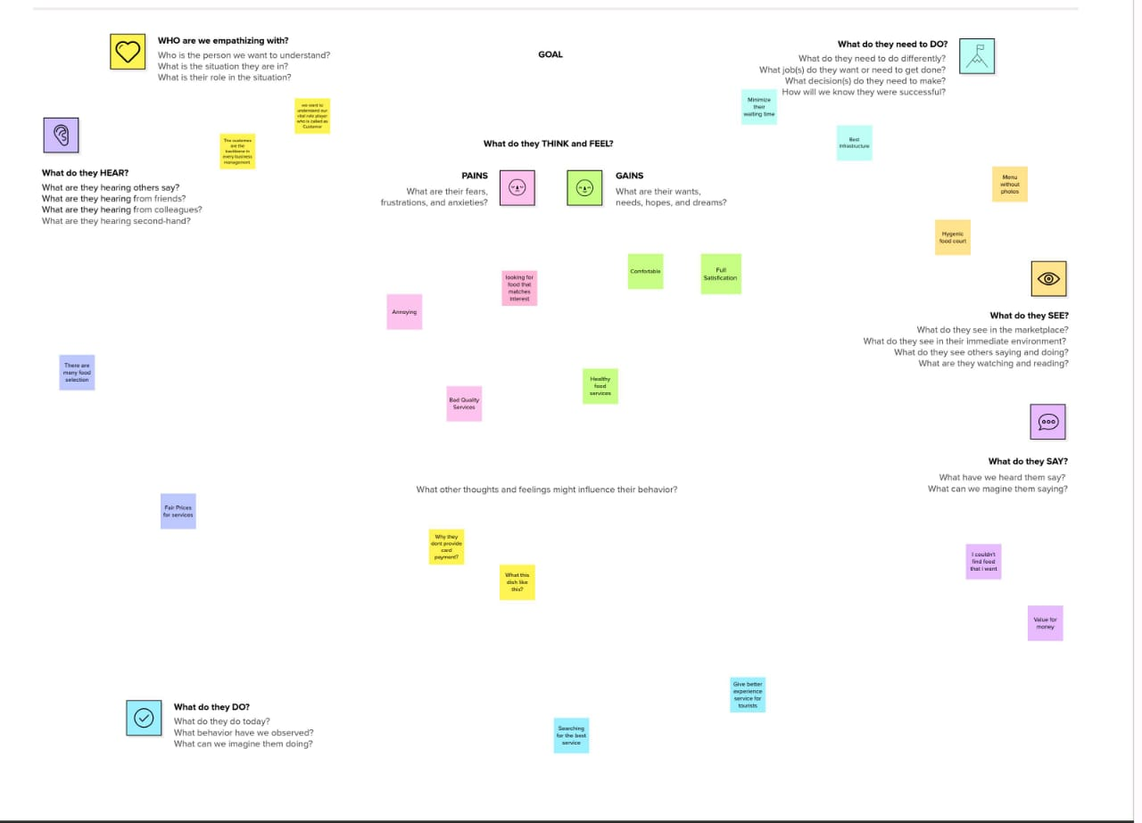

**2.2 Ideation and Brain Storming Map**

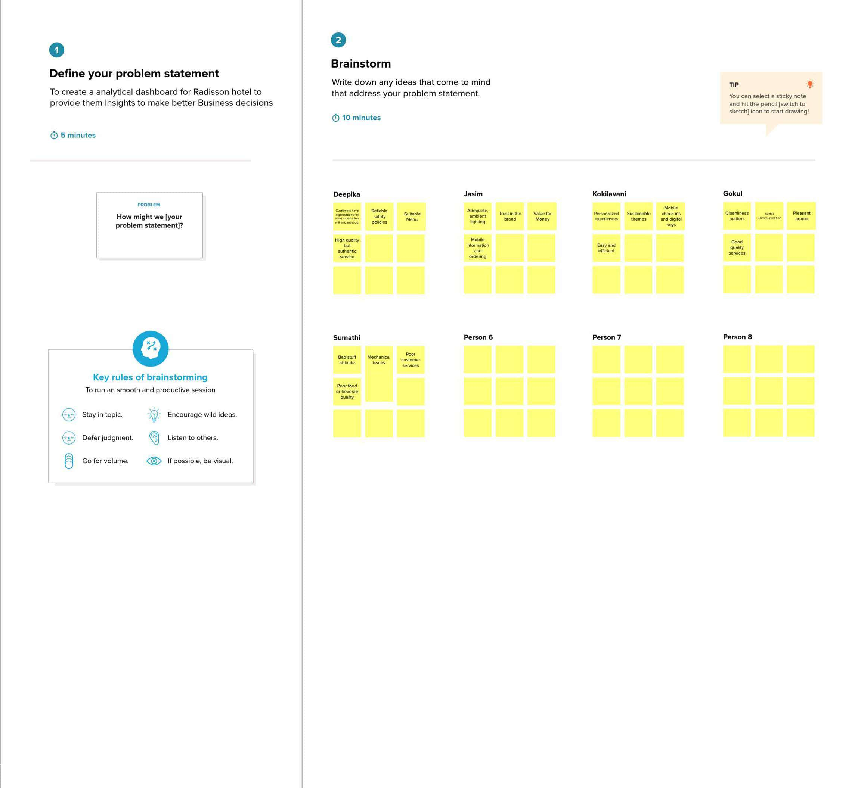

1. **RESULTS**

The outputs of Data Visualization

* 1. Revenue split by city

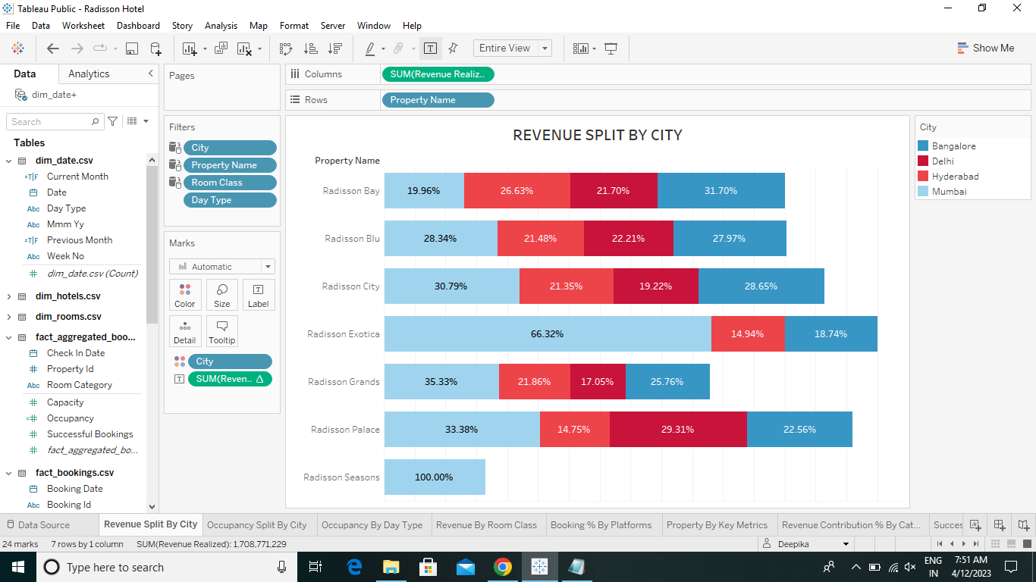

* 1. Occupancy split by city

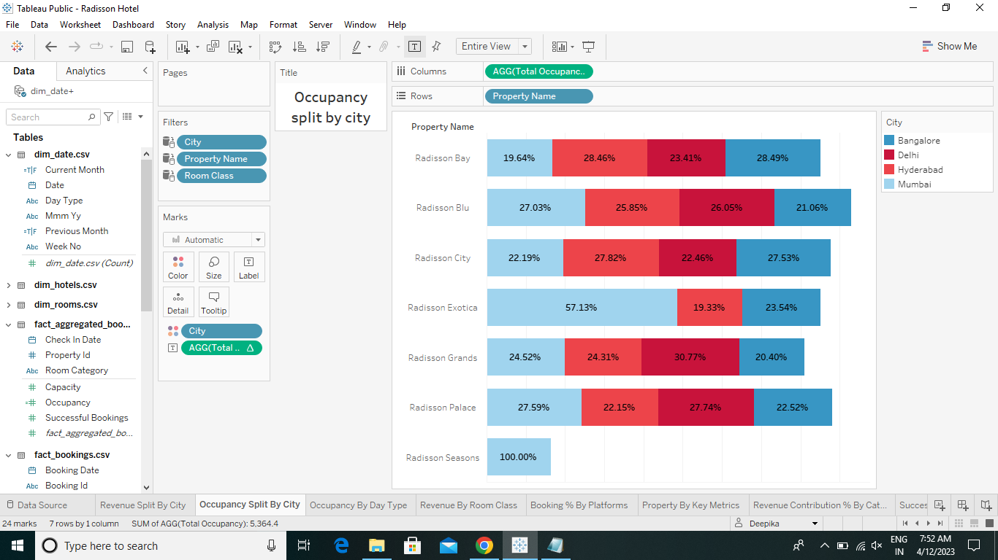

* 1. Occupancy by date types

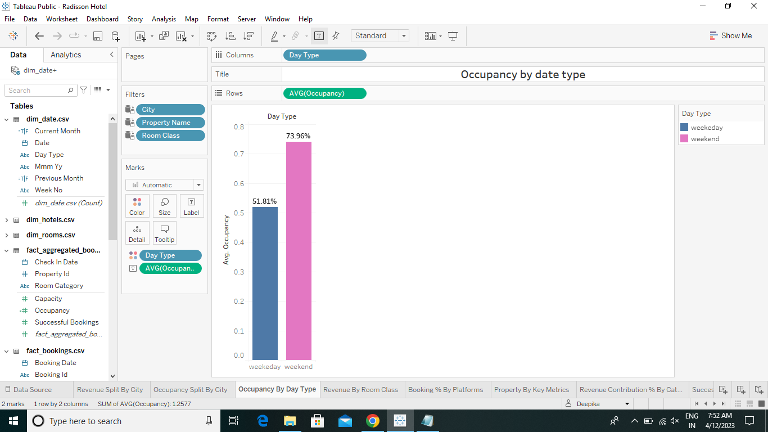

* 1. Revenue by room class

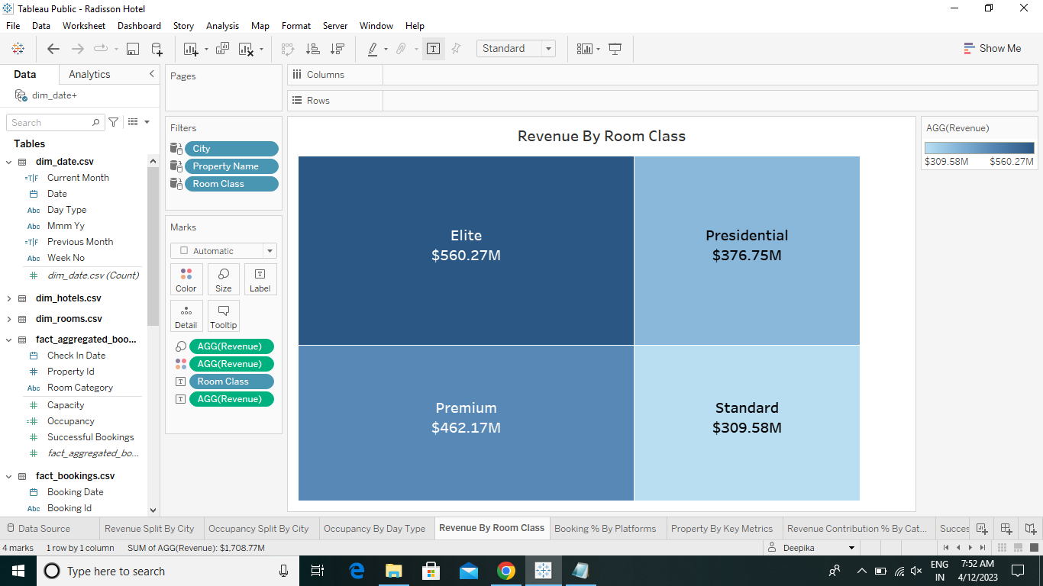

* 1. Booking % by platforms

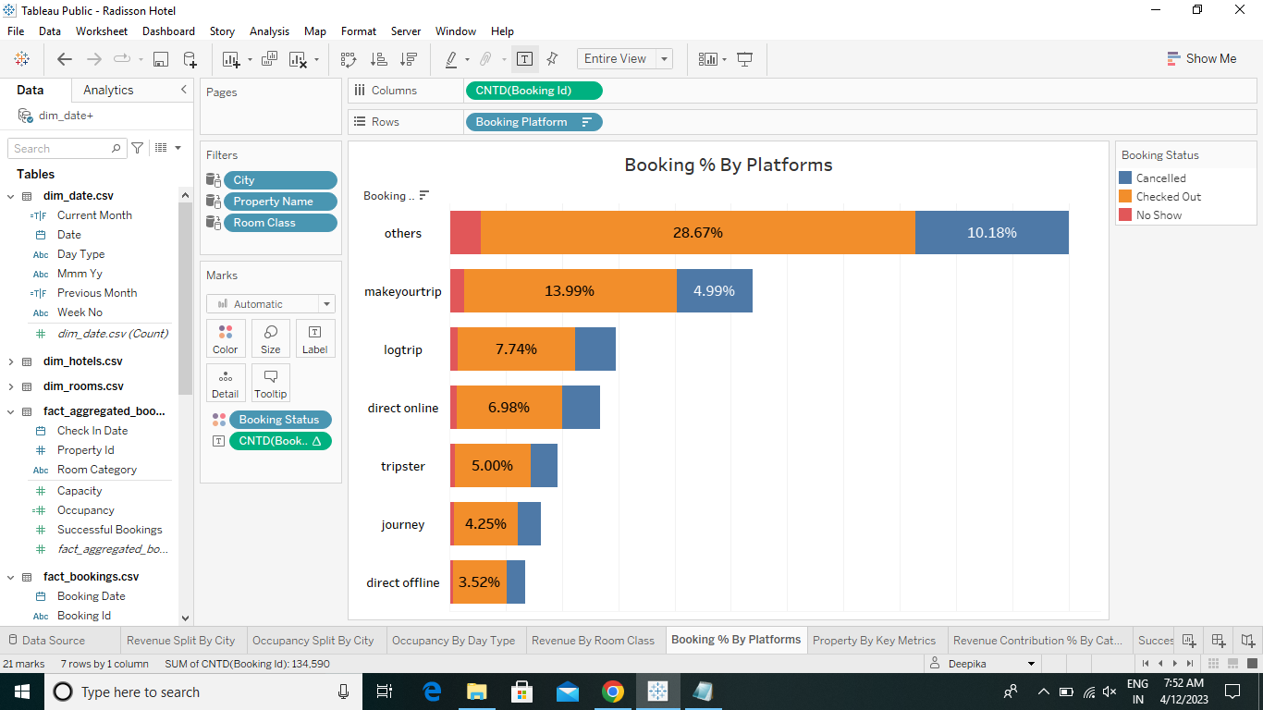

* 1. Property by key metrics

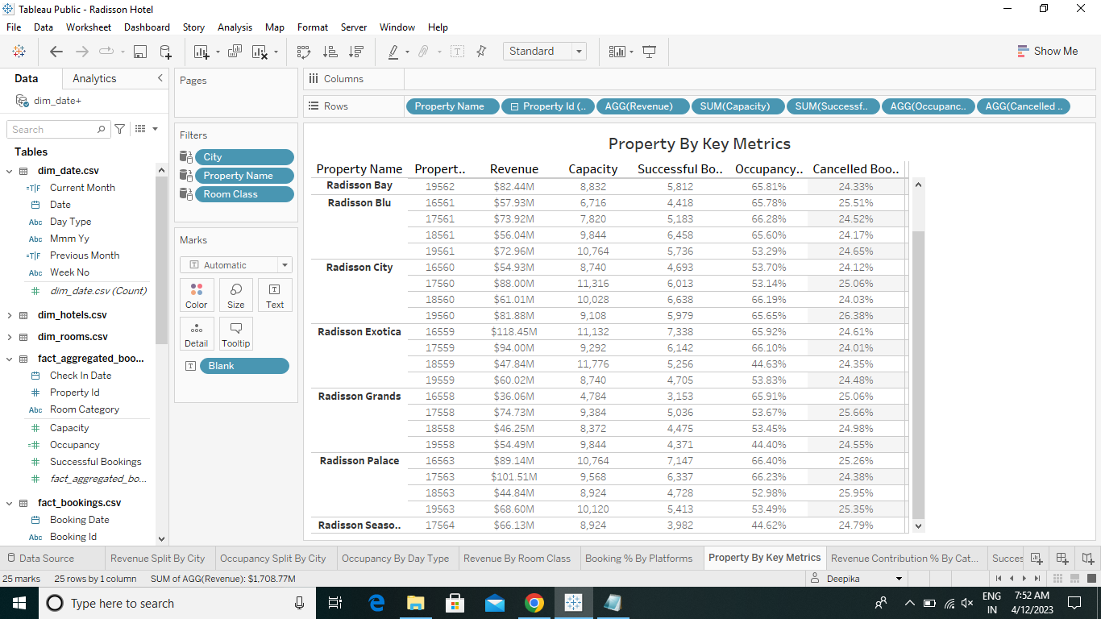

* 1. Revenue contribution % by category

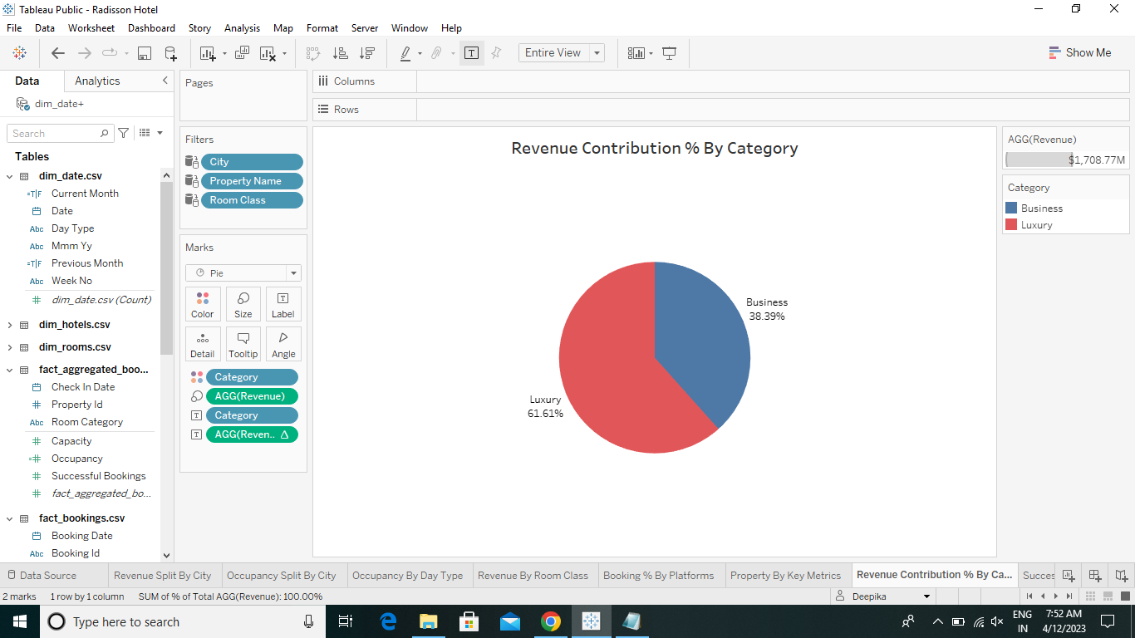

* 1. 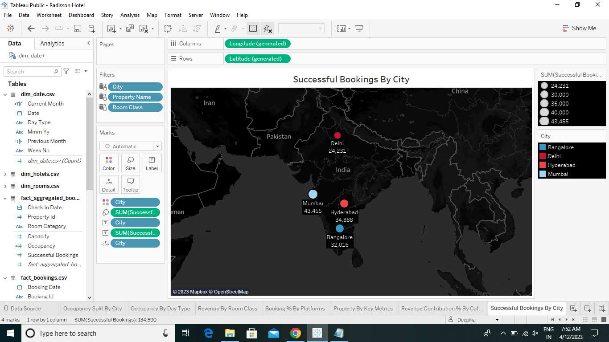Successful bookings by city
  2. Successful bookings by date wise

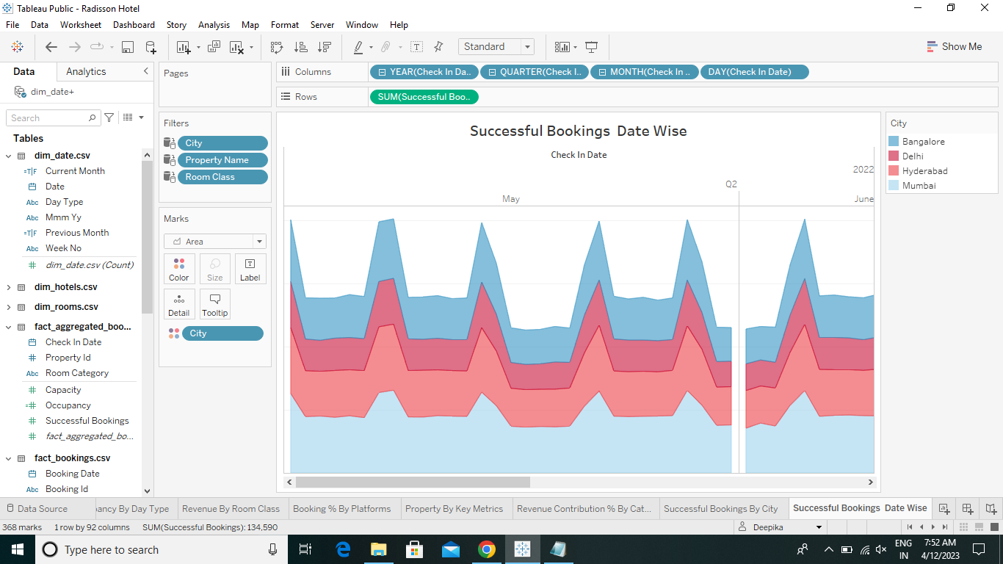

* 1. Total revenue for the hotels

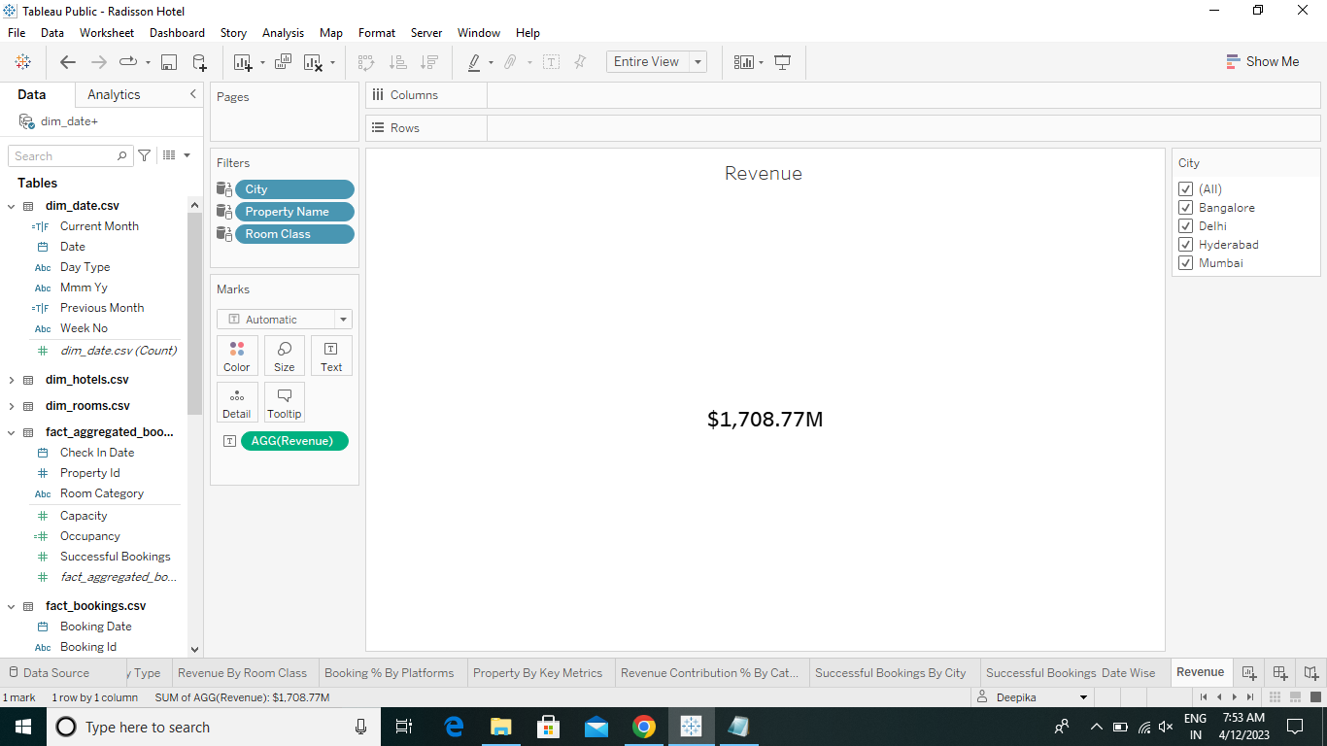

* 1. Total successful bookings

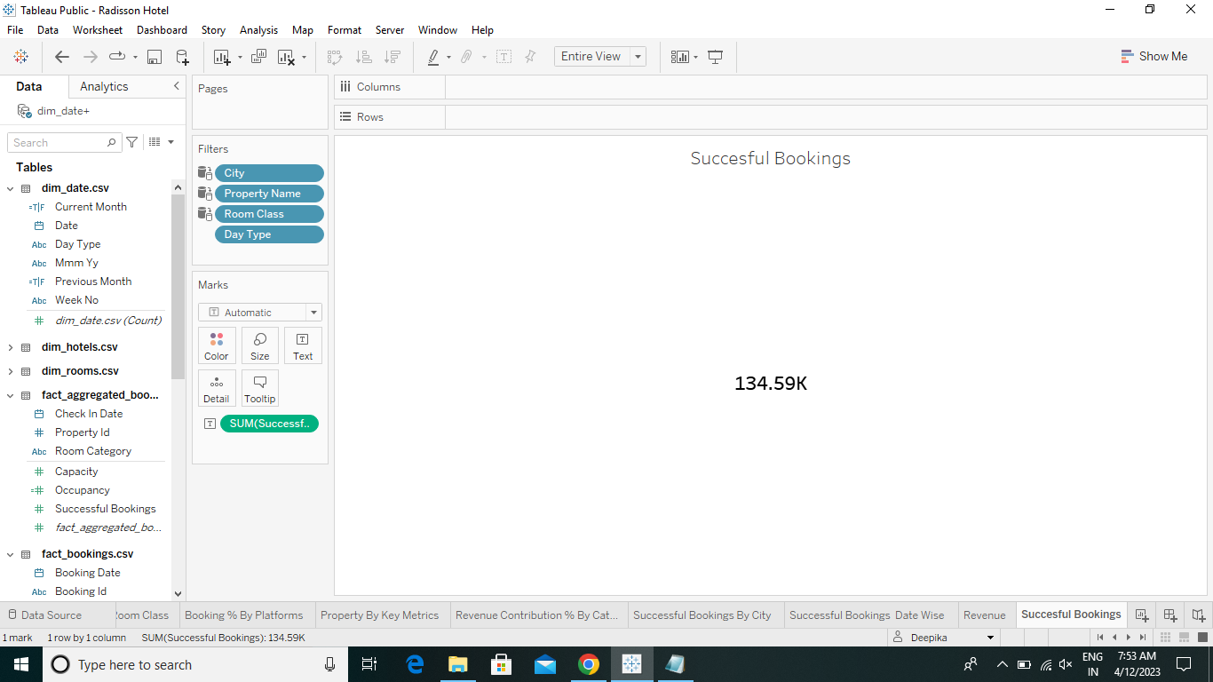

* 1. Occupancy by %

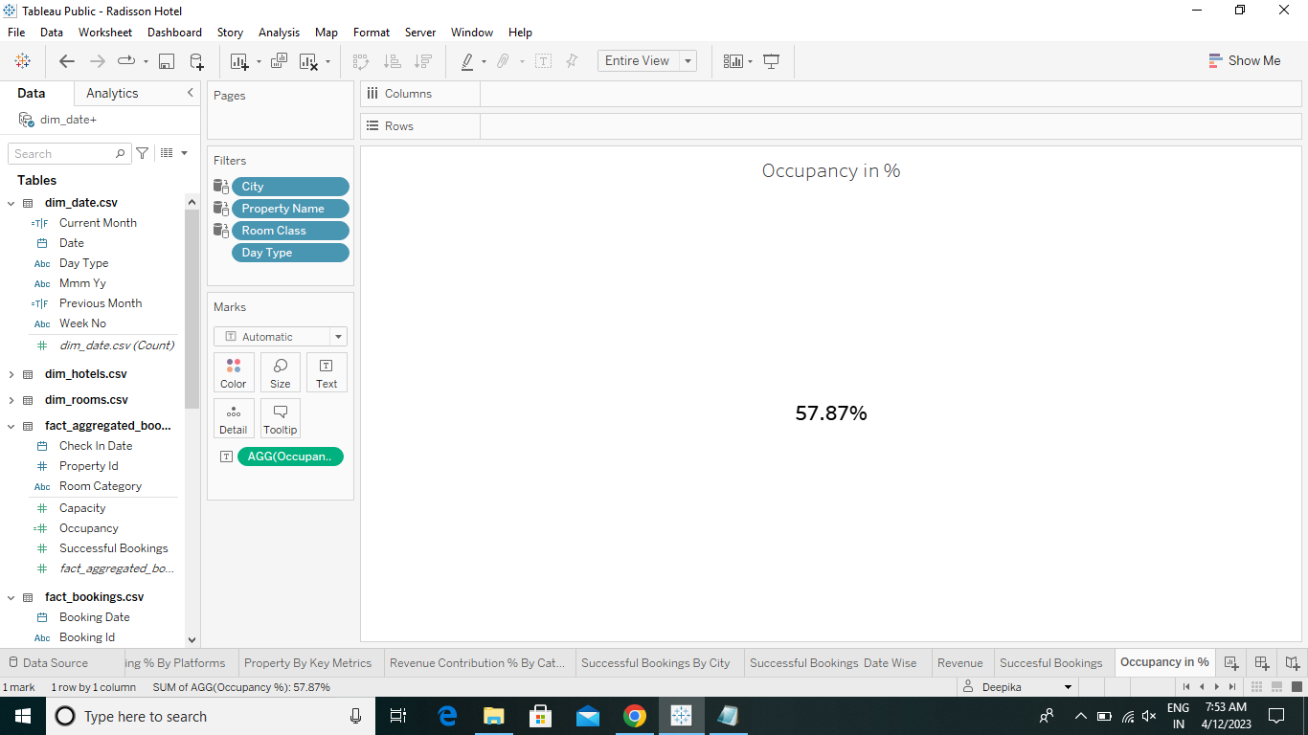

* 1. Dashboard

<https://public.tableau.com/app/profile/deepika6352/viz/RadissonHotelAnalysis/RadissionHospitalityAnalysis>

* 1. Story

<https://public.tableau.com/app/profile/deepika6352/viz/RadissonHotel/Story1>

1. **ADVANTAGES AND DISADVANTAGES**

**Advantages**

**REDUCED OPERATIONAL COSTS**

Hotels can easily cut their energy consumption by 20-35% without changing a guests’ experience or comfort. By reducing how much energy your hotel uses, you can lower energy bills, lower your operating costs and lower your carbon footprint.

**IMPROVED HOTEL IMAGE**

As a hotelier, it’s wise to show you’re working on your corporate social responsibility. Promoting your green activities on your website, through social media, in your hotel lobby and guest room directories will help to improve your brand image.

**MEETING CUSTOMER DEMAND**

Hotels can use this to their advantage by positioning themselves as an eco-alternative. Showing that you’re actively reducing your hotel’s energy use can meet the demand for eco-conscious travelers. Meaning your hotel attracts a new clientele while staying a step ahead of the emerging sustainable trend.

**Disadvantages**

**HIGH STANDARDS AND TIGHT DEADLINES**

The hospitality sector is all about doing everything possible to make sure that the customer is satisfied. The clients can be demanding and so can be the management**.**

**CANCELLATION OF BOOKINGS**

The longer a room is booked in advance, the higher is the risk that it will be cancelled. The actual amount of cancellations from early bookers rises approximately 1 month before arrival. Contrary, the so-called last minute bookings, which are made up to 10 days before arrival are less likely to be cancelled than the early ones**.**

**CUSTOMERS REVIEWS**

Now the modern online era, most of the peoples uses the customers reviews for their further bookings. Suppose the low level of ratings will leads to minimize the arrival of the customers. It affects the profit of our hotels.

1. **APPLICATIONS**

With the help of this analysis the hotel management should know the followings:

1. The profit and the losses due to checked out and cancellation
2. Mumbai was the received high number of bookings then compare to others.
3. Total revenue and occupancy rate in weekdays and weekends.
4. The online platforms which the customers mostly used.
5. Leads to take appropriate decision to increase their profit and decrease the losses.
6. **CONCLUSION**

The Analysis the performance and efficiency of the Radisson hotels that helps the hotel management for increase their performance and make changes in that area where they meet the needs of the customer. The data visualization represents the revenue, the hotels occupancy, the successful bookings by date wise as well as city wise, etc. It helps the management to analysis the factors that affect their business and take correct decision.

1. **FUTURE SCOPE**

The Hotel eliminate their affecting factors which brings development to the hotels, they regain their social status. They know their customer demands that leads to increase their revenue capacity and give a better brand image.